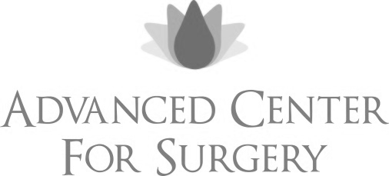

Dear Surgical Patient,

I would first like to thank you for the confidence you have shown by selecting me as your surgeon. Whether your surgery is elective or not, you should know that I will do everything I possibly can to achieve an ideal post-operative outcome. There are unfortunately some consequences and complications associated with any surgical procedure and these should be considered in more detail. I hope that our discussions regarding your particular procedure have provided you with a complete understanding to your satisfaction; however, it may be impossible to list all of the potential outcomes or complications and this document is only aimed at providing more information for you.

There is no particular order to these events and their place in the list does not imply the possibility for you developing any or all of them.

Infection
Swelling
Delayed Wound Healing
Delayed Bone Healing
Fracture
Pain
Numbness
Allergy to medicines
Joint Stiffness
Loss of limb or life
Loss of tissue or bone
Scarring
Blood Clots
Loss of function
Need for Rehab/Therapy
Need for braces or orthotics after surgery
Need for other surgery
Anesthesia complication
Limitations in activity

In addition to the above, individual patients may also have unforeseen allergies to materials such as: sutures, hardware, screws, staples, bonegraft or any other materials utilized by the surgeon or surgical staff.

Some of these outcomes may be only temporary if they happen, while others may be permanent. You should also understand that even with all of the advances and new technologies available in medicine and surgery, no guarantees can be given or implied as to the outcome of your procedure.

If you have any further questions please bring them to my attention or call the office at any time.

Sincerely,

Adam M Budny, DPM

